
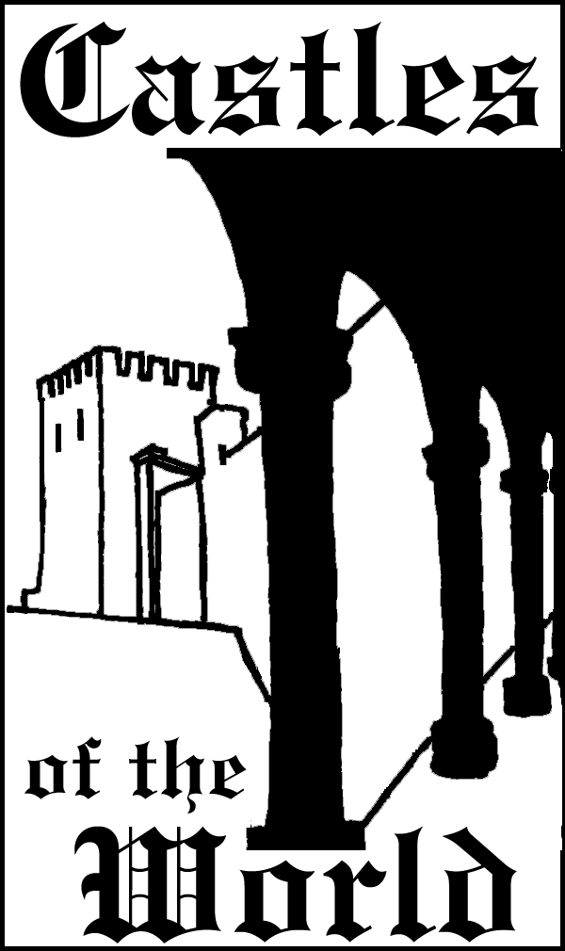
4110 St. Michael’s Ct  Sugar Land, TX. 77479-2913  USA | www.castlestour.com  Phone: 281 265 2620  Fax: 281 265 2621

15 days GREAT CASTLES TOUR 2001
US$ 2,290.00 PER PERSON, LAND ONLY
“It’s the best vacation we ever took”
Karen & Ben from Virginia
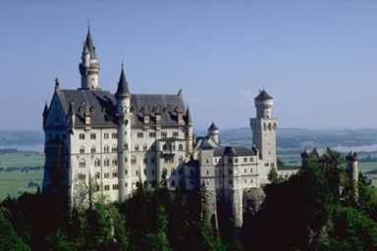 |  | Leaving from your  home country:  Friday, June 15, 2001  and  Friday, August 31, 2001 | 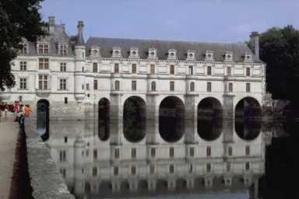
First class escorted tour with English Speaking tour guides.  Excellent Hotels and delicious meals.  Tour operated by GLOBUS, first class touring since 1928. | 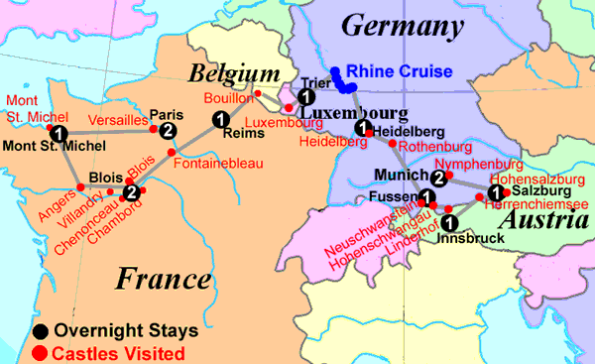 | US $100.00 deposit is required by February 15 or April 30.  Space is Limited

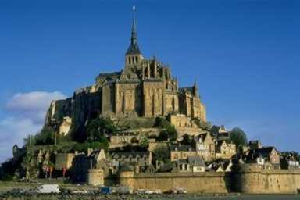 |  | For more information or reservations contact:  Lucy Fernandez  lucy@castles.org  Phone: 281 265 2620  Fax: 281 265 2621 |  | 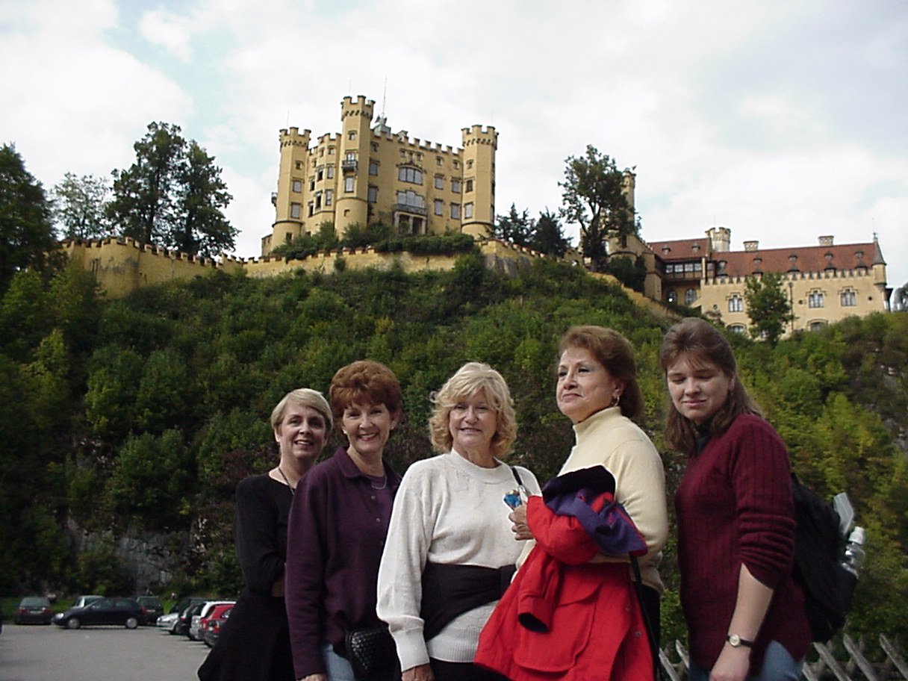
 | “The tour fulfilled my castle fantasies; it was everything I dreamed of and more. I was expecting Errol Flynn to fly through on a rope any second. I feel like I got an overview of every notable castle in Europe. The cost was reasonable and the accommodations were even better than I expected. Thanks for all of your effort & planning!”
 | Mary Ann and Joe from Texas
ITINERARY
DAY 1 – FRI
Board your flight from your home country to Paris, France.
DAY 2 - SAT PARIS, FRANCE
Meals included: Dinner
Upon arrival, pass through customs and meet your tour director and waiting motor coach. Transfer to your hotel. Remainder of the day is at leisure to rest or start exploring the city. Welcome drink and dinner at a Restaurant in the Montmartre area includes an illuminations tour of Paris. (D)
DAY 3 – SUN PARIS
Meals Included: Breakfast
In the Morning, guided visit to the PALACE AND GARDENS OF VERSAILLES, the retreat of French royalty at the height of absolutistic power. Admire the sumptuous reception rooms, the intriguing Hall of Mirrors, the famous fountains and formal gardens. Lunch on your own at Versailles. Afternoon visit of Paris, including a guided visit to the top level of the EIFFEL TOWER to admire the superb panorama over Paris and the LOUVRE MUSEUM. (BB)
DAY 4 – MON PARIS - MONT ST. MICHEL
Meals included: Breakfast and Dinner
Drive directly to Mont St. Michel. Arrive at St. Michel for lunch. Inside visit of MONT ST. MICHEL, perched on a rocky isle in the Gulf of Saint Malo. Its awesome fortifications were attacked many times during the Hundred Years War, but never captured. Local guide included. Free time until dinner. (BB, D)
“Seeing so many interesting places in such a short time, was the best, even though we might have been rushed in times, we got MORE FOR OUR MONEY......”
Bill from Los Angeles
DAY 5 – TUE MONT ST. MICHEL - BLOIS
Meals included: Breakfast and Dinner.
Stop in Angers and visit the impressive 13th century ANGERS CASTLE, with its moat and soaring towers, inside visit included. After lunch drive to VILLANDRY visit the splendid terraces and gardens, inside visit included. Then to Blois in the Loire Valley. (BB, D)
DAY 6 – WED BLOIS
Meals Included: Breakfast
A rich day of sightseeing. Drive through the 13,600 acres park of CHAMBORD. This impressive Renaissance chateau has a magnificent staircase designed by Leonardo de Vinci. Inside visit with local guide. Drive to lovely CHENONCEAU, the 16th century chateau of Catherine de Medici, inside visit included. In the afternoon visit the castle of BLOIS. It is the work of the Kings of France Louis XII and Francois I, guided visit included. Dinner on your own at Blois for an excellent opportunity to explore the fine French cuisine. Meet after dinner for the SOUND AND LIGHT SHOW AT BLOIS CASTLE. (BB)
DAY 7 - THU BLOIS - REIMS
Meals included: Breakfast and dinner
Drive from Blois to Fontainebleau. Visit FONTAINEBLEAU PALACE, lavishly built and furnished in the Renaissance period style, was a favorite hunting residence of the French kings. The apartments occupied by Napoleon were recently restored and are included in our tour. Inside visit with local guide. Drive to Reims to have an orientation tour, which includes a guided visit of the GOTHIC CATHEDRAL OF REIMS. Visit the Cathedral where French kings were crowned, and where Joan of Arc arranged the consecration of Charles VII. Visit a champagne cave to learn about the fine art of champagne making. (BB, D)
Day 8 – FRI REIMS - TRIER, GERMANY
Meals Included: Breakfast and dinner
Drive from Reims to Bouillon. Stop in the small town of Bouillon in the south of the Belgium for a visit of BOUILLON CASTLE, famous from the first crusade. Inside visit with local guide. In the afternoon, focus on Luxembourg, the last of hundreds of independent duchies which once made up western and central Europe. Today the Grand Duchy owes its importance to its role in international politics and banking. Your orientation tour of the stately capital features the Ducal Palace. Drive to pretty Trier for overnight, one of Germany's oldest towns, Its Porta Nigra is considered one of the finest Roman relics in Northern Europe. Orientation tour in Trier. (BB, D)
“There is a wonderful diversity of castles of different styles and periods. Local guides enhanced the experience by providing historic background and interesting stories of those who lived there.”
John from Virginia
Day 9 – SAT TRIER - HEIDELBERG
Meals Included: Breakfast and Dinner
Leave Trier for a Rhine Cruise. Short CRUISE ON THE RHINE RIVER. Leave Rhine Area to Heidelberg. Continue on to Heidelberg, Germany's oldest university town of Student Prince fame. Sightseeing focuses on the RED WALLED CASTLE, where the great vat, a 49,000 gallon 18th century wine cask attracts particular attention, local guide included. Dinner and overnight in Heidelberg. (BB, D)
Day 10 – SUN HEIDELBERG - FUSSEN
Meals Included: Breakfast and Dinner
Leave Heidelberg to ROTHENBURG. Visit spectacular Rothenburg with its ramparts and towers, cobbled lanes and 16th-century houses. Orientation tour plus shopping time. Afternoon drive to Fussen. (BB, D)
Day 11 – MON FUSSEN – INNSBRUCK, AUSTRIA
Meals Included: Breakfast and Dinner
Drive into the garden-like landscapes of the Bavarian Alps. Spend much of this morning at Mad King Ludwig's fanciful NEUSCHWANSTEIN CASTLE, Germany’s best-known tourist attraction. Inside visit with local guide included. See the beautiful Hohenschwangau, where Ludwig lived as a child. In the afternoon visit, LINDERHOF CASTLE. Enjoy a guided visit of Ludwig II's romantic hunting lodge in the densely forested valley of the Ammergau Alps. Marvel at the grandeur of its splendid staterooms and see the light and play of its terraced water GARDENS. Dinner and overnight in Innsbruck. (BB, D)
Day 12 – TUE INNSBRUCK - SALZBURG
Meals Included: Breakfast and Dinner
Drive to Innsbruck for orientation tour. Afternoon excursion to HERRENCHIEMSEE PALACE, inside visit with local guide. Includes one-way horse carriage ride, boat ride and entrance fee. Arrive at Salzburg for dinner and overnight. (BB, D)
Day 13 – WED SALZBURG – MUNICH, GERMANY
Meals Included: Breakfast and Dinner
Visit the castle of HOHENSALZBURG, inside visit with local guide. Includes round trip of the funicular to the castle. Orientation tour of Salzburg. A pleasant stroll that will take you to the historic center of Mozart's hometown, admire exquisite Mirabell Gardens, the Baroque horse trough, the Great festival Hall. St Peter's Churchyard and the monumental Domplatz. See the Sound of Music grounds. Continue to Munich. Overnight and dinner in Munich. Dinner at the Houfrahaus, see a traditional Bavarian dance and entertainers such as alpenhorn blowers and yodelers. (BB, D)
Day 14 – THU MUNICH
Meals Included: Breakfast and Dinner
Orientation tour of Munich. Lunch at the Marienplatz to watch the Glockenspeil at noon. Afternoon visit to NYNPHENBURG PALACE, inside visit with guide. Visit the MARSTALLMUSEUM, with the coaches and riding gear of the royal families. Farewell dinner and overnight in Munich. (BB, D)
Day 15 – FRI MUNICH - RETURN HOME COUNTRY
Meals Included: Breakfast
Group transfer to the airport to meet return flight home. (BB)
End of our services
“Trying to re - live in person a piece of history I've only read about in school long ago, to hear the sound of thundering horses, the smell of torches and the archers crossbow, arrows whizzing by are the stuff Hollywood and lessons are made of and this brought all of this and many more alive, permanently etched in the minds of all who walked in the steps of kings! A sincere thanks!!!!!”
Rick from Philadelphia
 | TOUR DIRECTOR:  The services of a professional, multilingual Tour Director will be provided throughout. Practically all tips are included in your tour price. The only exceptions are for extra services not part of the tour program, such as laundry, bar services, etc. and tips to your tour director, or local host and driver. Although it is up to you to determine the gratuity you wish to give to your tour director and driver, we are often asked what would be a fair amount. The tip you give should always reflect your degree of satisfaction: for example, we suggest US $2 to $5 per tour day per tour member for the tour director, US $2 to $5 per day per tour member for your driver, and US $1 per person for the local guides.  MEALS:  Welcome Drink  Dinner at the Houfrahaus in Munich with folkloric show  (BB) 13 Buffet Breakfasts  (D) 10 Three - course Dinners with coffee or Tea | 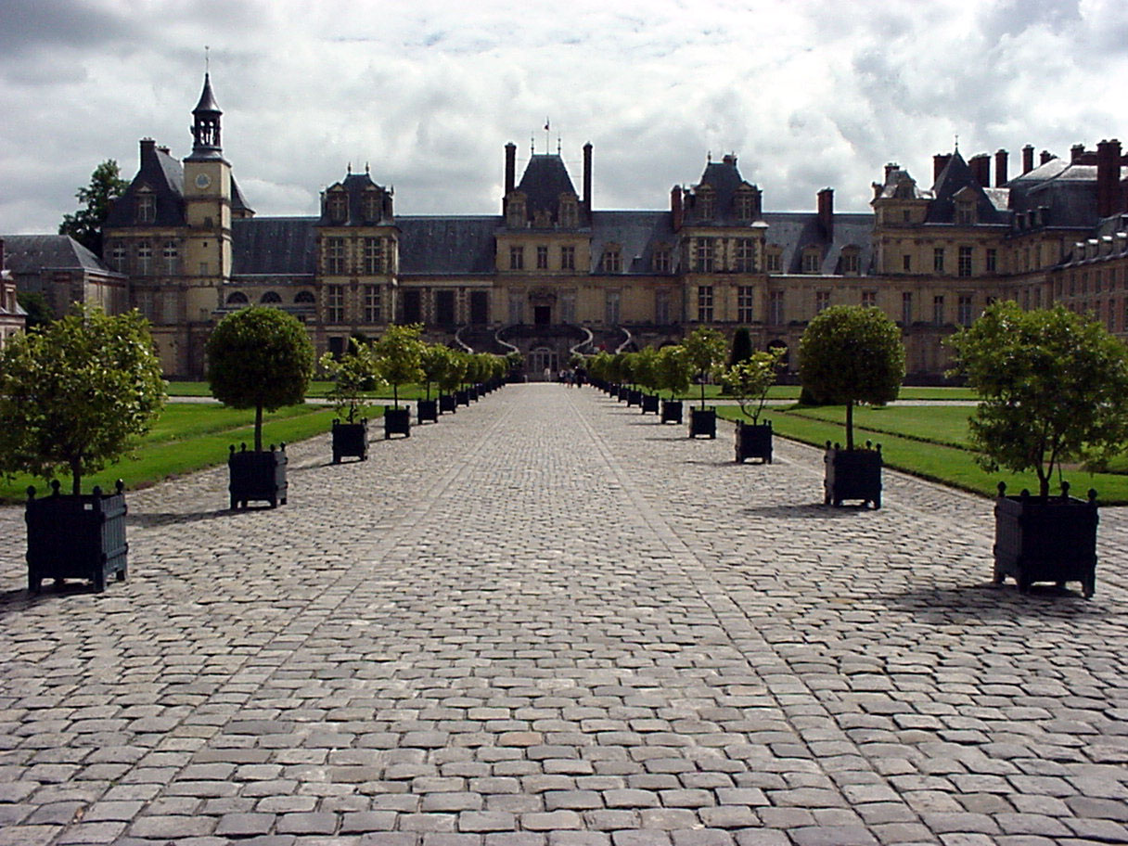
TRANSPORTATION:
Transportation to Paris and from Munich is not included in price. Transatlantic and any other air transportation are covered under separate arrangements. We will do our best to get the most affordable airline ticket, depending on city of departure. Private deluxe motor coach, air conditioning, extra legroom, and emergency washroom during the entire tour are included.
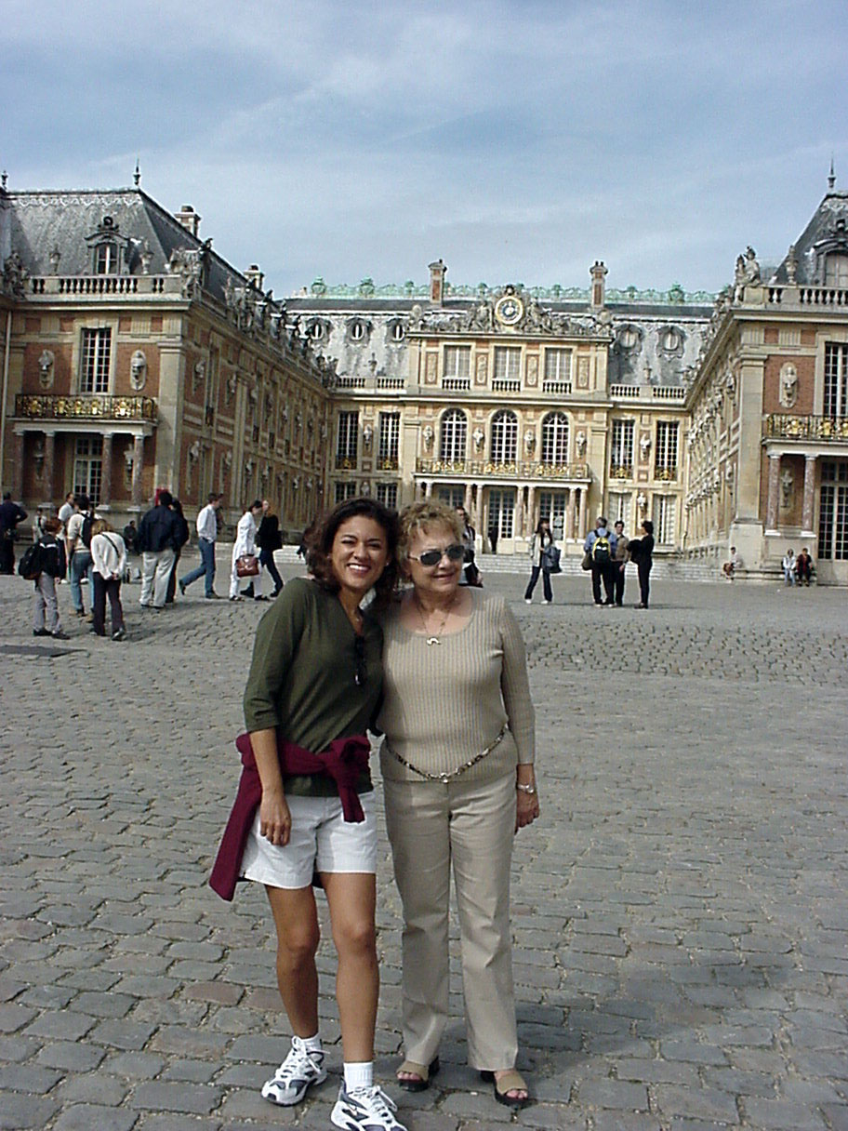
HOTELS:
Accommodations will be provided in first class hotels, or best available superior tourist class, twin bedded rooms with private bath or shower, based on double occupancy. Hotel taxes, service charges, state and local taxes, tips to baggage porters and hotel staff are all included in tour price. Three weeks prior to departure, you will receive a complete list of hotels, addresses and phone numbers.
CASTLES TO BE VISITED:
Versailles, Mont St. Michel, Angers, Villandry, Chambord, Chenonceau, Blois, Fontainebleau, Bouillon, Rhine Castles, Rothenburg, Heidelberg Castle, Neuschwanstein Castle, Hohenschwangau, Linderhof Castle, Herrenchiemsee, Hohensalzburg Castle and Nymphenburg Palace. Inside visits to all the mentioned castles are included except: Hohenschwangau, which is optional and the Rhine Castles, which are seen from the ship.
CITIES AND TOWNS:
Paris, Mont St. Michel, Blois, Reims, Luxembourg, Trier, Heidelberg, Rothenburg, Fussen, Innsbruck, Salzburg and Munich.
NOT INCLUDED IN TOUR PRICE:
Transportation to Paris and from Munich is not included in price.
Airport taxes, if applicable, excess baggage (one bag per passenger), meals not included in itinerary, all items of a personal nature such as laundry, cleaning, telephone, beverages including tea and coffee (except at breakfast and hotel diners) wines, liquors, soft drinks, etc. and tips to motor coach driver, tour director and local guides.
BAGGAGE HANDLING:
Throughout your tour, hotel porters are standing by to carry your suitcase to and from the motor coach and your room. Porterage and tips are included in the price of your tour. One suitcase 30" x 18" x 10" and weight not exceeding 60 lbs. is permitted. Globus will provide each passenger with a complimentary travel bag, which we recommend taking on the trip.
